1. compress filename

uncompress filename.Z

gzip filename

gunzip filename.gz

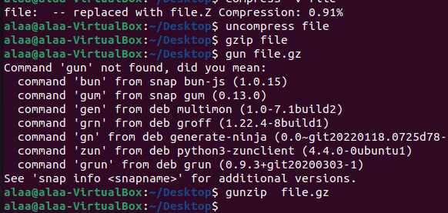

1. Zcat file.Z

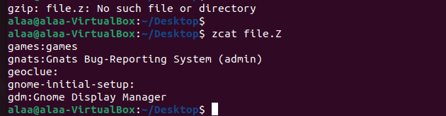

1. sudo tar czvf etc_backup.tar.gz /etc

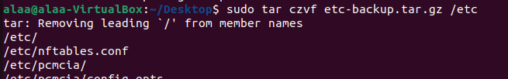

4-find ~/ -mtime -2

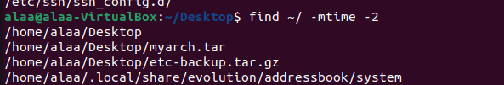

1. sudo find /etc -user root

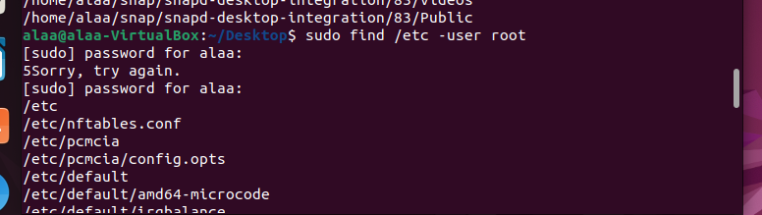

6-find ~ -type d

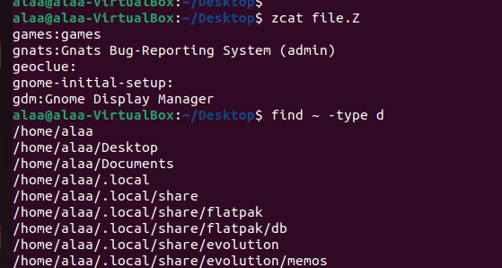

7- find / -type f -name ".profile"

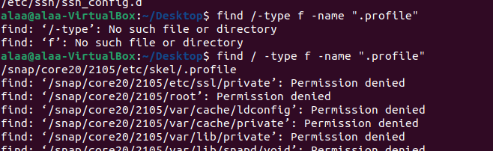

8- file /etc/passwd

file /dev/pts/0

file /etc

file /dev/sda

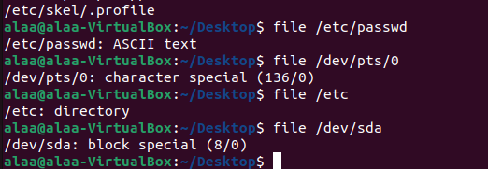

9-ls -i /

ls -i /etc

ls -i /etc/hosts

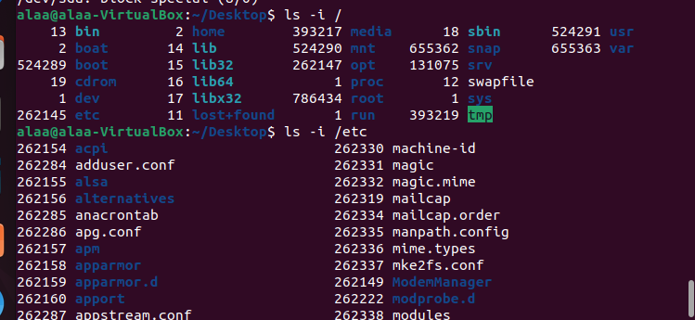

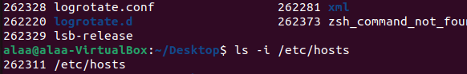

10- cp /etc/passwd ~/passwd_copy

diff /etc/passwd ~/passwd_copy

cmp /etc/passwd ~/passwd_copy

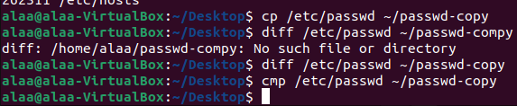

11-sudo ln -s /etc/passwd /boot/passwd_link



12- You cannot create a hard link of **/etc/passwd** in the **/boot** directory. Hard links can only be created for files within the same filesystem. Both the source and destination for a hard link must reside on the same filesystem because a hard link is essentially a direct reference to the inode of the original file.

In most Unix-like systems, the **/etc** directory and the **/boot** directory are on separate filesystems for various reasons, such as security and performance. Due to this separation, you cannot create a hard link between a file in **/etc** and a file in **/boot**.